**Roberta (Felipe Fogo x17136865)**

**MCTV Financial Accountant’s recommendation**

As the financial accountant I believe that going forward capital should be invested in an integrated accounts package. All the options I have below offer cloud services, which is a key tool if we want to be on top of our business.

There are numerous advantages of moving to cloud.

Cost effectiveness and scalability come together, in my option. Not only it will cost less to maintain data in the cloud but you also would not have to worry about business growth and buying or upgrading servers and related equipment. Cloud services are easy and quick to set up and require no maintenance.

Our data can be safely and quickly accessed from anywhere at any time. Data would no longer be restricted to our LAN and it can be accessed 24/7 from a laptop or mobile phone. Data in Sage 50 cloud is secure, and according to their website they have been working tirelessly on implementing GDPR so they are in compliance with the new data protection rules, which will be in place from 25 May 2018.

The only problem I see with having our accounting done in the cloud is that we depend on at least average internet connection to access our data.

Although alternatives to Sage 50 Cloud share some of its features for a lower price I would still opt for Sage. Being more robust and with the option to integrate seamlessly with Sage Pay and Microsoft Office 365 makes sage the most cost beneficial of the four solutions I found.

**Costs and Benefits**

Going with Sage 50 Cloud Professional the investment would be of €155/month

Manage cash flow, income, expenses and payments.

Create Invoices and quotes

Manage VAT

Secure cloud access and backup

Mobile apps

Track and manage Stock

**Other Options**

* **FreshBooks**

FreshBooks seems to focus more on making small business invoicing and billing simple but that does not cover half of our needs.

* **QuickBooks**

Although offering some of the same features as Sage 50 Cloud Professional, I feel that Quickbooks is more of a transition solution and a final one.

* **Xero**

Xero’s selling points are security, reliability and time-saving tools. Which are all also offered by Sage 50 Cloud Professional.

**Conclusion**

I strongly believe that Sage 50 Cloud would make all the difference to MCTV business. The advantages by far outweigh the only disadvantage of migrating to the cloud.

**USER GUIDE**

The first thing you have to do is to create a Sage account so you can download the softwares.

Go to Login > My Sage > Create a Sage logon

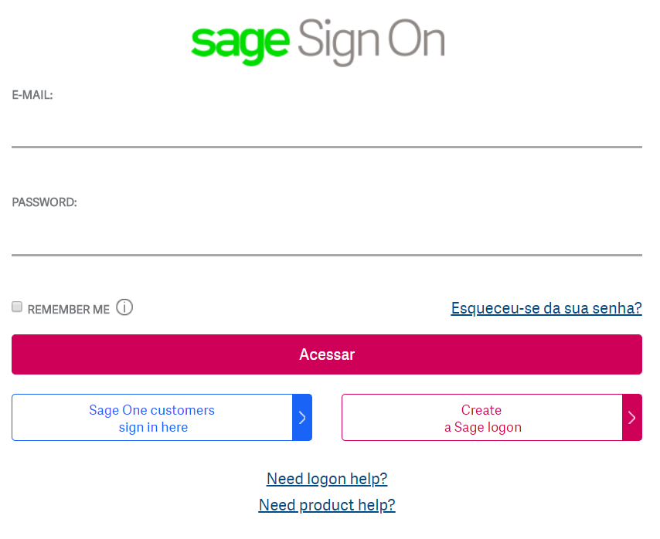

You will be asked to enter your Name, Email and password

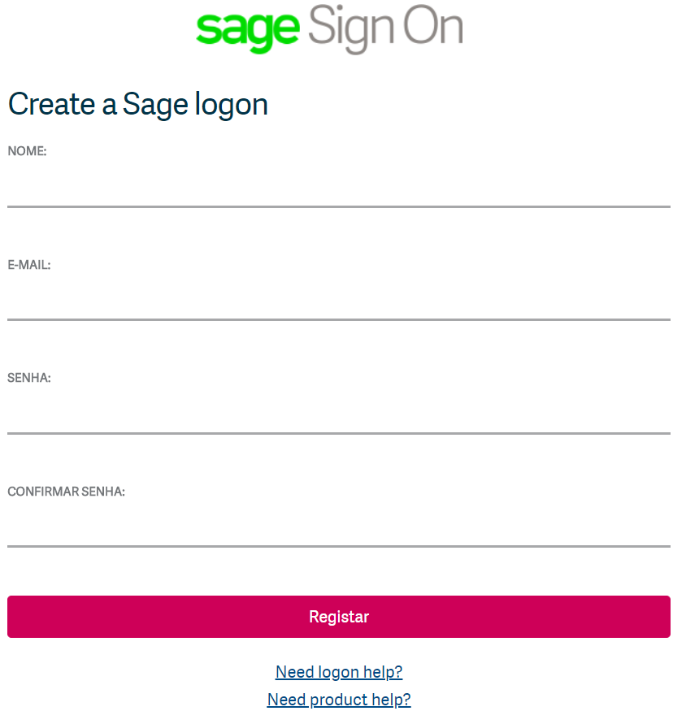

Having Sage 50 Accounts this is the home page

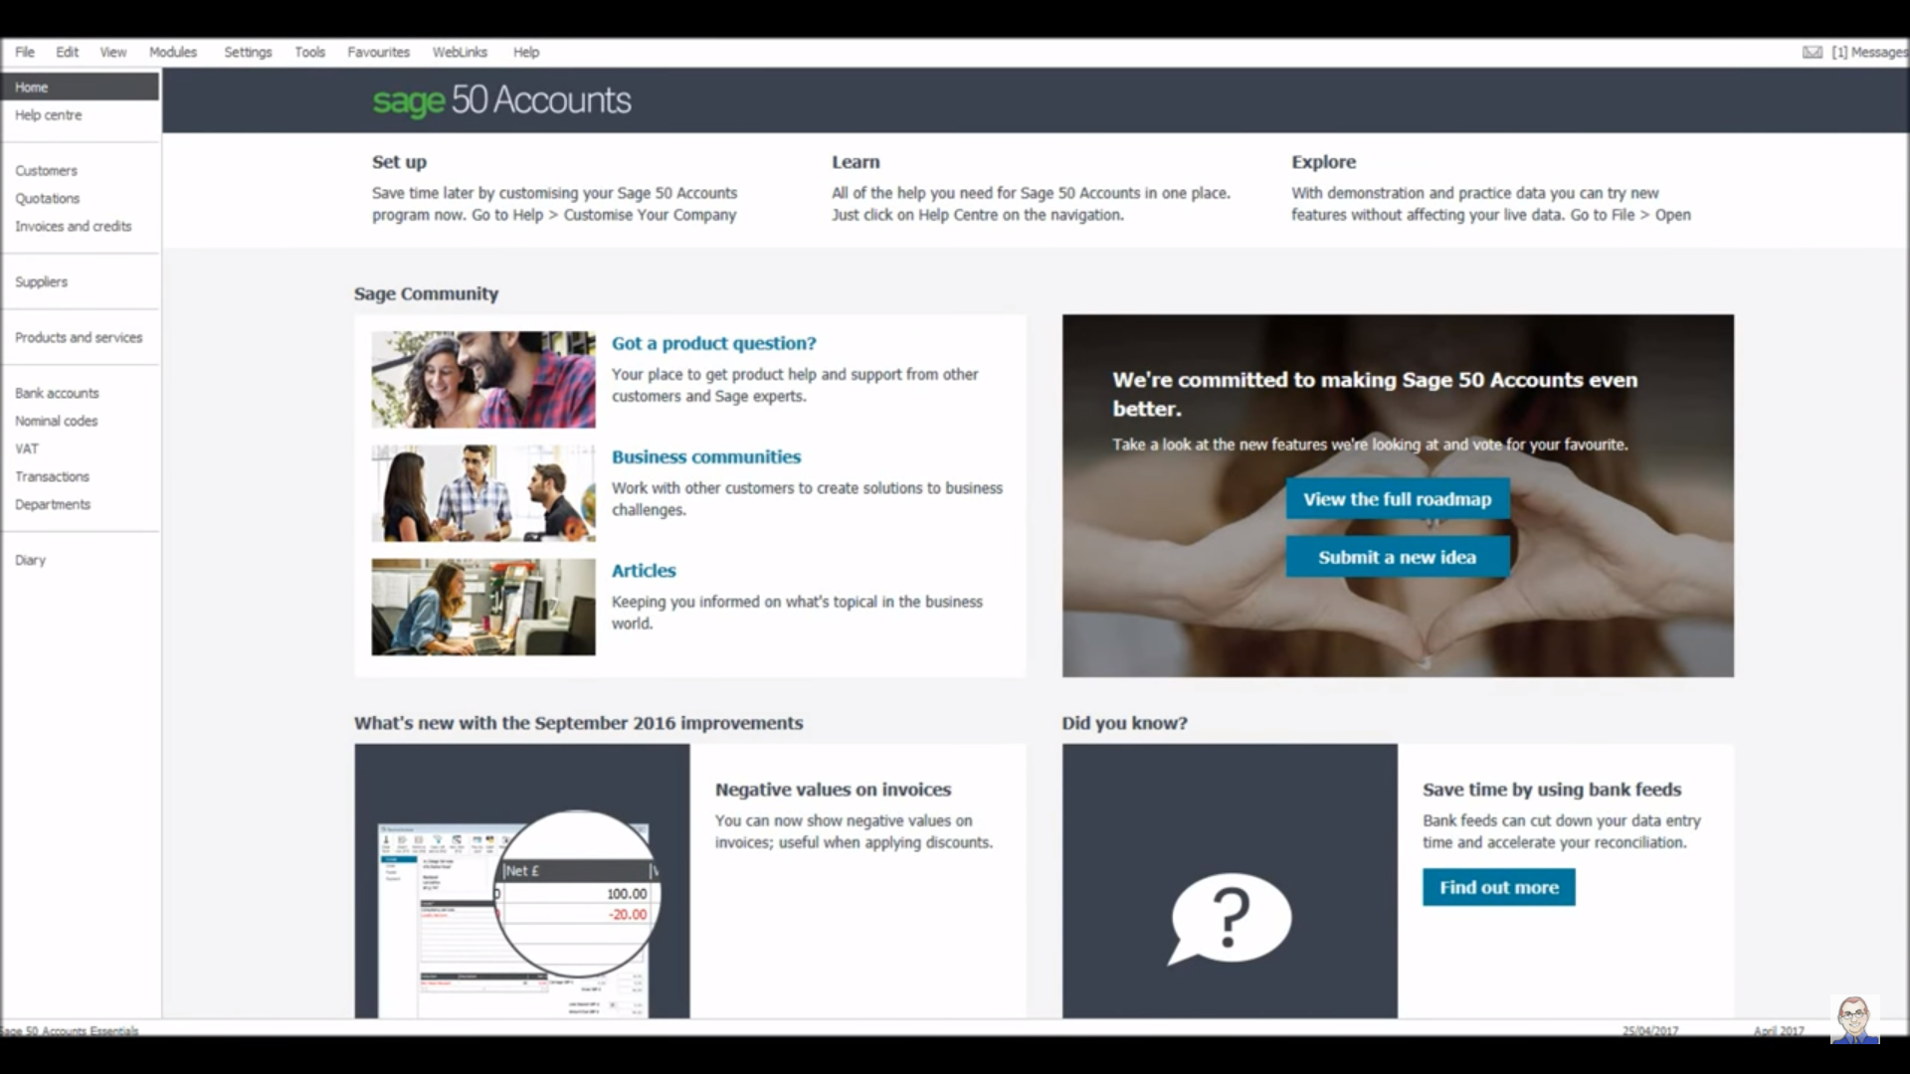

Suppliers session - When you want to check, alter or add a Supplier go to Suppliers on left side menu

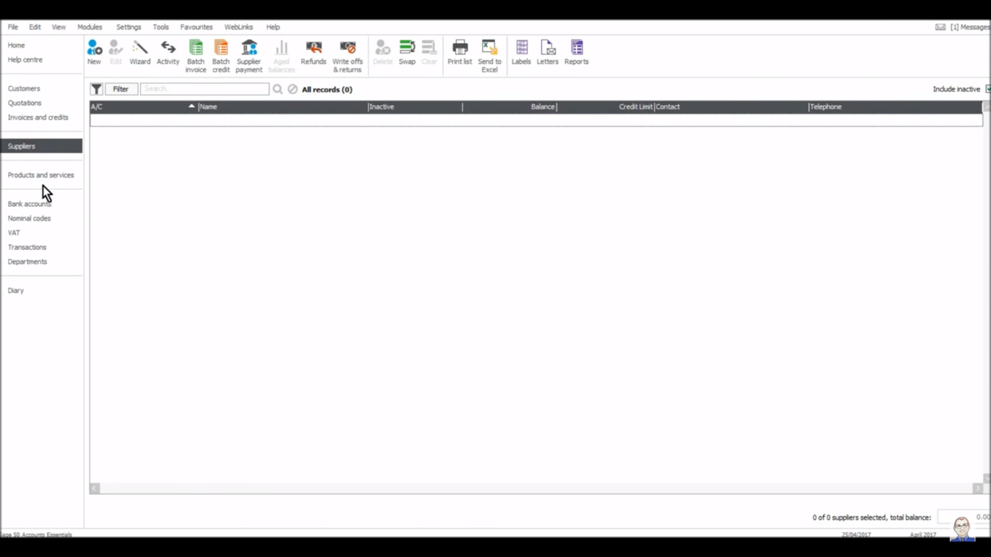

Next you click on Wizard at the top toolbar. This step is straightforward. You will be asked

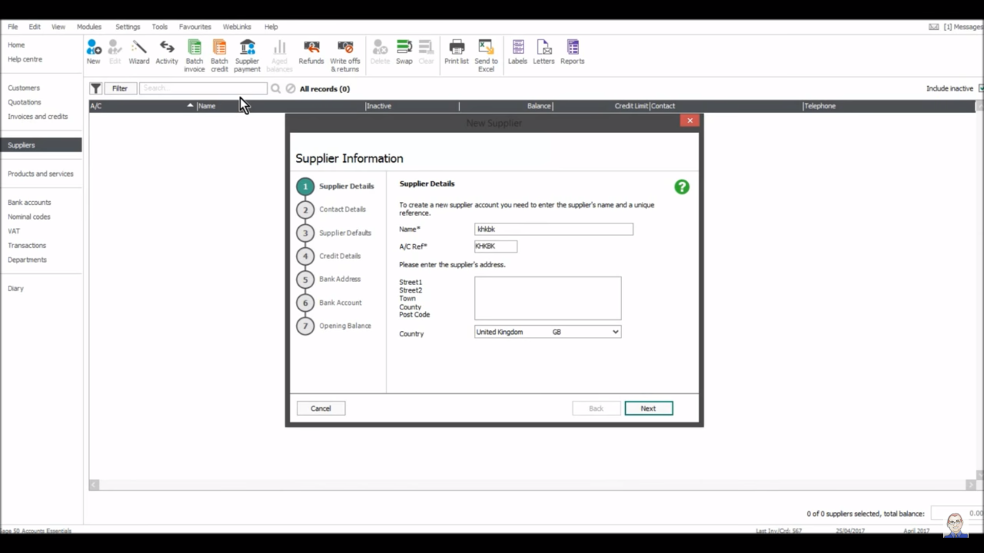

You have seven sections to fill out:

* Supplier Details: Name and Address.
* Contact Details: Phone, Email, Website, VAT Number.
* Supplier Defaults: Nominal and Tax codes.
* Credit Details: Limit, Settlement Due Days, Payment Due Days.
* Bank Address: Bank Name and Address.
* Bank Account: Account Name, IBAN and BIC, Sort Code, Account Number BACS/SEPA Ref.
* Opening Balance: You might add an opening balance is the supplier has any outstanding invoices or credit notes.

After you are finished filling out all sections you click “create”.

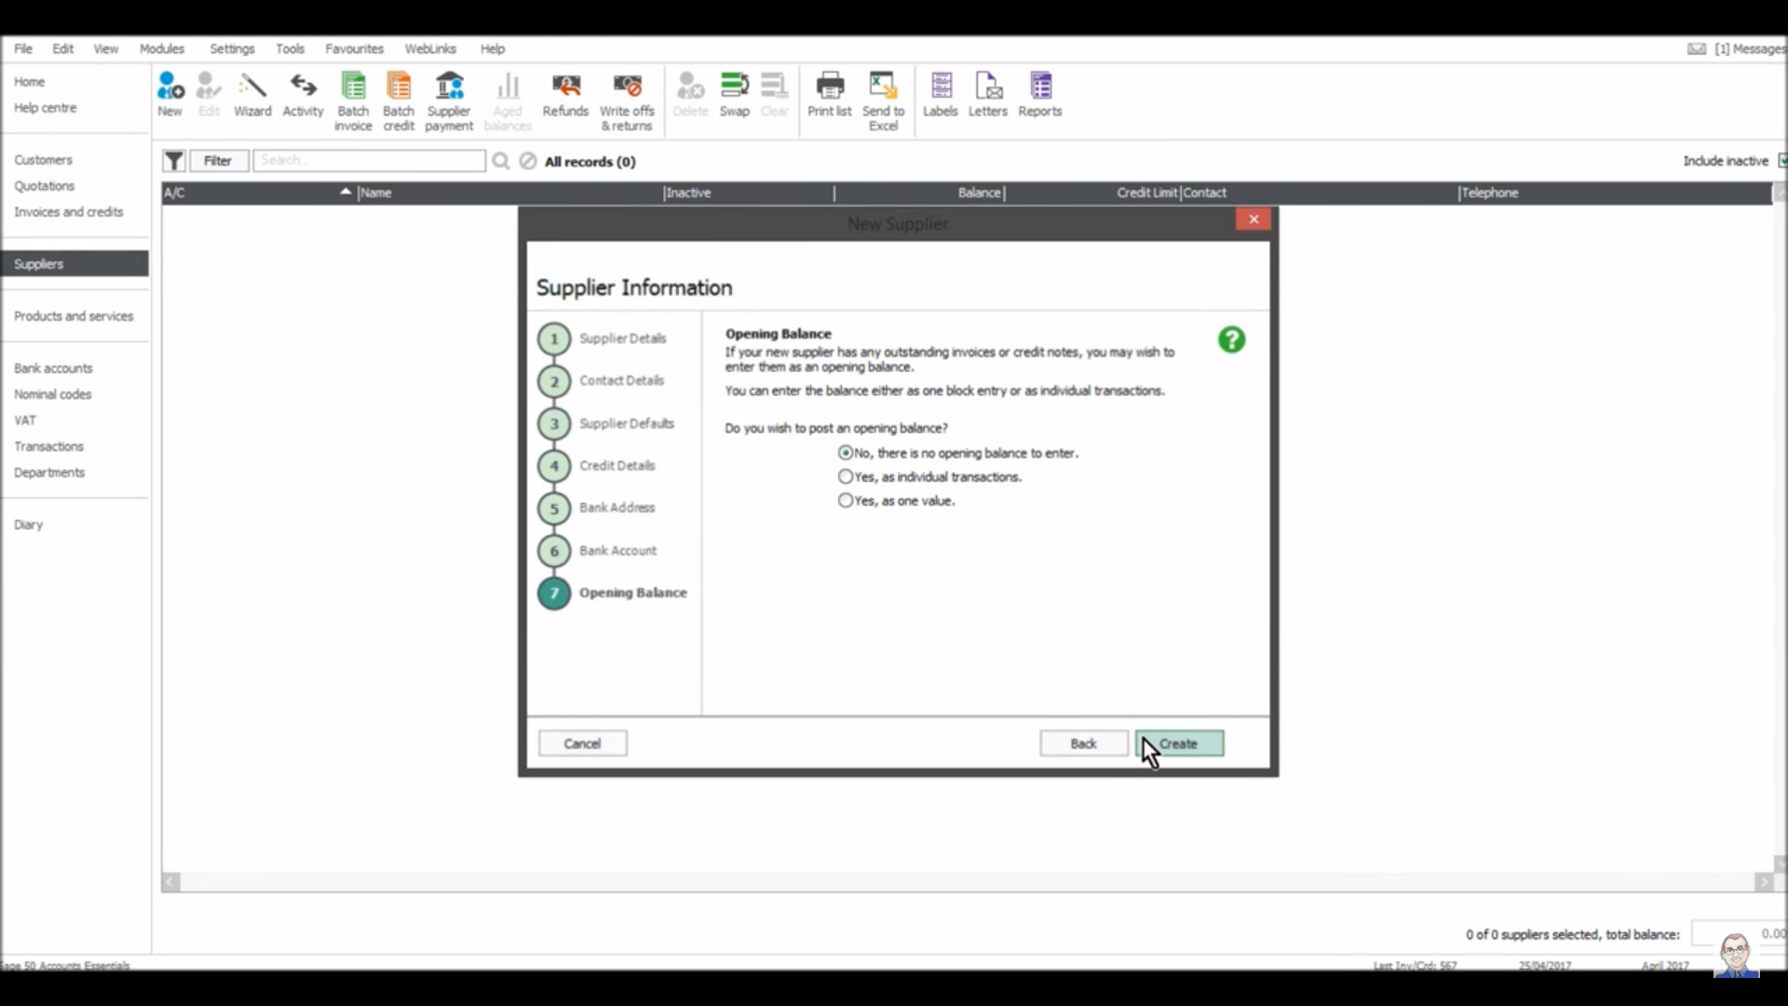

You should see the new supplier add there on the main section.

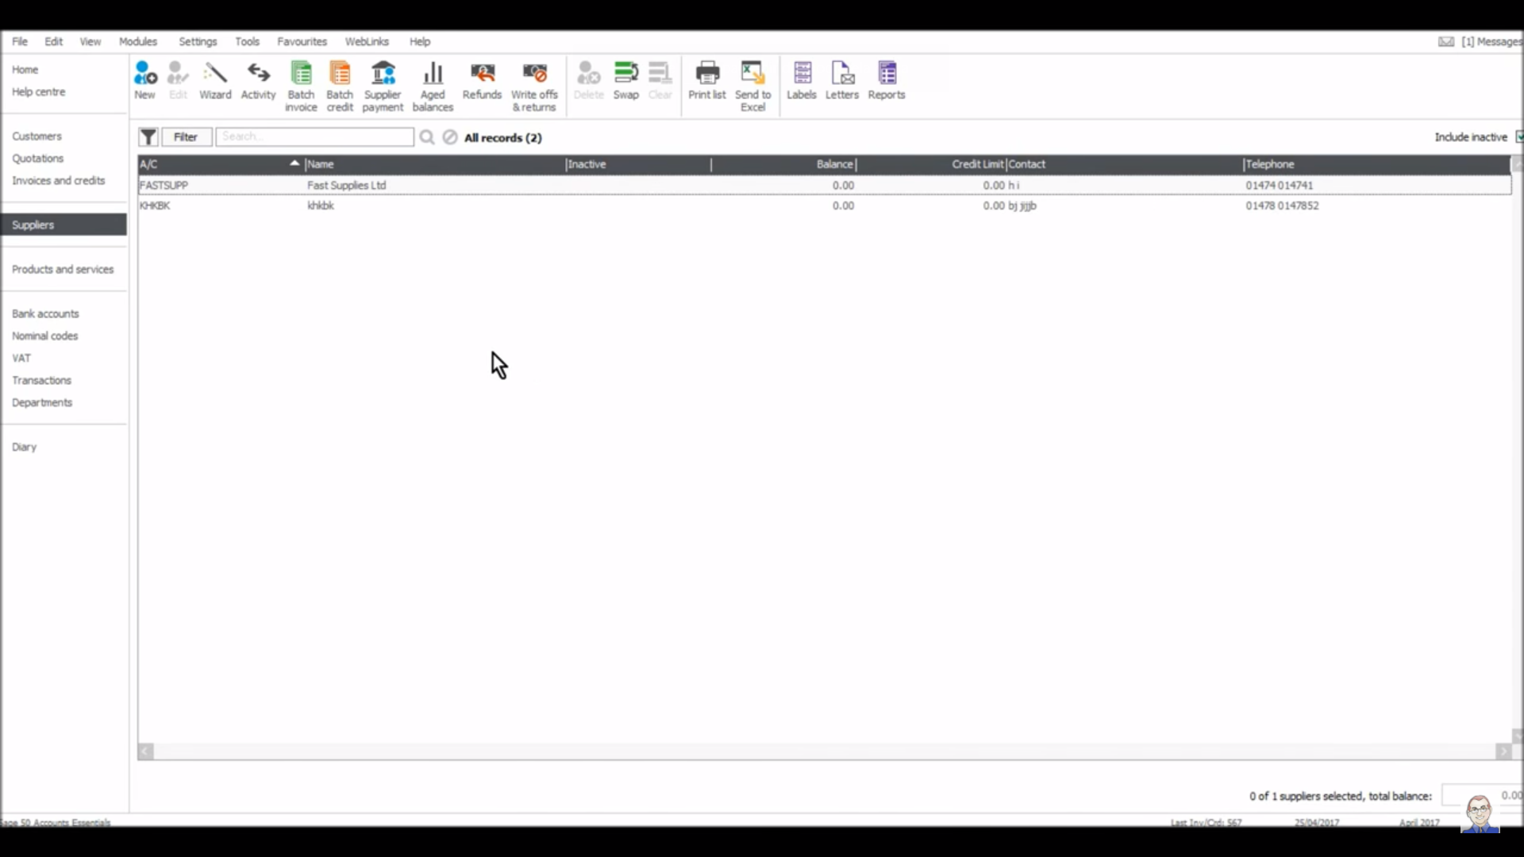

**Linking Microsoft Excel to Sage 50 Accounts data**

These are the basic steps that explain how to link Microsoft Excel to your Sage 50 Accounts data when you have multiple companies set up in Sage 50 Accounts. They include:

To check your data directory

1. Help > About.
2. Program Details section > note the data directory.
3. Sage 50 Accounts 2011 and below - System Information > Directories > note the data directory in the right-hand pane.

To link to Microsoft Excel 2007 or above

1. Open a new Microsoft Excel worksheet, or the worksheet that you want to connect to your Sage 50 Accounts data.
2. Data > Get External Data section > From Other Sources > From Microsoft Query.
3. New Data Source > OK.
4. What name do you want to give your data source? > enter a name for the new data source, for example the company name.
5. Select a driver for the type of database you want to access > choose the required driver for your version, for example Sage Line 50 v18 > Connect.
6. User ID > enter your Sage 50 Accounts username > Password > enter your Sage 50 Accounts password.
7. Data path > enter the data directory for the company, including ACCDATA > OK > OK > OK.
8. Complete the Query Wizard to choose the required data for your query.

To link to Microsoft Excel 2003

1. Open a new Microsoft Excel worksheet, or the worksheet that you want to connect to your Sage 50 Accounts data.
2. Data > Import External Data > New Database Query.
3. New Data Source > OK.
4. What name do you want to give your data source? > enter a name for the new data source, for example the company name.
5. Select a driver for the type of database you want to access > choose the required driver for your version, for example Sage Line 50 v18 > Connect.
6. User ID > enter your Sage 50 Accounts username > Password > enter your Sage 50 Accounts password.
7. Data path > enter the data directory for the company, including ACCDATA > OK > OK > OK.
8. Complete the Query Wizard to choose the required data for your query.

|  |
| --- |
|  |

**References**

My.sage.co.uk. (2018). Ask Sage - How to link Microsoft Excel to Sage 50 Accounts data. [online] Available at: https://my.sage.co.uk/public/help/askarticle.aspx?articleid=11850 [Accessed 20 Apr. 2018].

Anon, (2018). [online] Available at: https://www.freshbooks.com/pricing#feature-list [Accessed 20 Apr. 2018].

Quickbooks.intuit.com. (2018). Accounting software to run your business online - QuickBooks. [online] Available at: https://quickbooks.intuit.com/global/ [Accessed 20 Apr. 2018].

Xero. (2018). Accounting Software | Xero. [online] Available at: https://www.xero.com/ie/try/accounting-software/?gclid=Cj0KCQjwn-bWBRDGARIsAPS1svvF8ayhfzS2OcFvV6wmC-ci3KeEMIG7Qi84U2Mx_InGLfI_6AM0DQ4aAtInEALw_wcB&gclsrc=aw.ds&dclid=CIf9xvvjytoCFR2ZdwodauAD7g [Accessed 21 Apr. 2018].

Brownell, J. (2018). Create a New Company File in Sage 50- Instructions. [online] TeachUcomp, Inc. Available at: https://www.teachucomp.com/create-a-new-company-file-in-sage-50-instructions/ [Accessed 21 Apr. 2018].